Farm Hack
Farm-to-farmer innovation; open source; creative commons

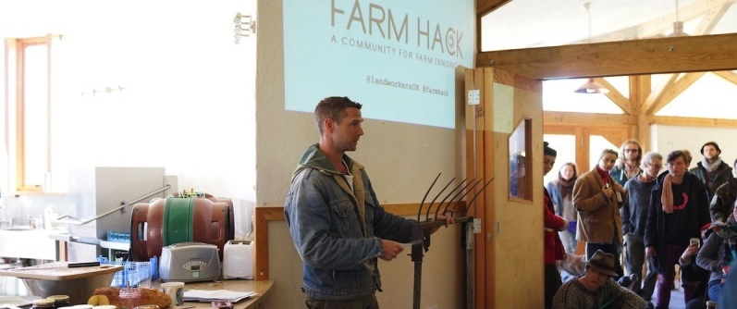

“At my place, its very hard to get something between a tractor and a trowel. There just isn’t much in between. It’s nice to come to places like this [Farm Hack event] and get energised and inspired. Cross-pollinate, swap-ideas, whinge about the weather. Lots of things. It’s very fruitful.”
– Kate Collins. Market Gardner, UK.

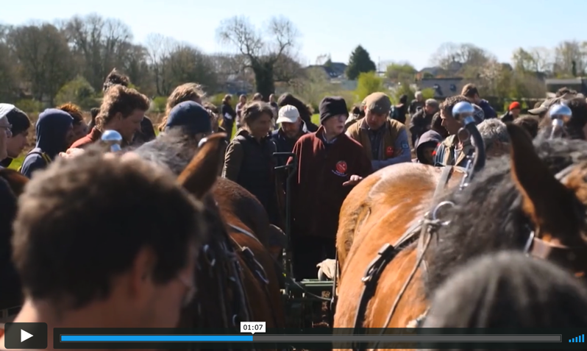
Farm Hack
Video 1 - Farm Hack was first started in the USA and is coordinated by an organisation called the Greenhorns. Available at: https://vimeo.com/73504647
Farm-hack is a community led approach to the development, modification and sharing of designs for farm tools, machinery and other innovations. It emphasizes a farmer-to-farmer approach to learning and creates platforms for farmers to come together to ‘hack’ and apply their collective ingenuity in the development of technologies appropriate for agroecological farming.
The first Farm Hack was originally started by The Greenhorns in the U.S.A., and has since been taken up in the U.K. Farm Hack typically involves two main complimentary components:
Web-based: A web platform is used to where designs can be shared using an open source or creative commons approach. Thus, farmer-derived innovations are made available and editable by other members of the community.
Events: Farm hack events bring together farmers, growers, fabricators, engineers and IT programmers to demonstrate and share tools, skills and ideas through field demonstrations, practical workshops, seminars, entertainment, and cultural exchanges.
These two components are interconnected where tools demonstrated at events are posted on-line.
Farm Hack provides a forum for collaborative innovation, learning and the building of community. Small farm agroecological technologies can then be developed and built by farmers and communities themselves.

Many tools are unavailable on the market - where they are available they can be very expensive and can create dependence on machinery inputs from corporate suppliers. This can reduce[reduces?] the autonomy of farmers. By bringing farmers and other technology creators together, new capacity for learning and innovation is created, leading to new innovations in terms of improved tools and increased confidence to develop and build tools.

In Practice
Video 2 - Farm Hack Scotland. Available at: https://www.youtube.com/watch?v=HZiYFJHfO-8&feature=youtu.be
In Europe, Farm Hack is used in the UK and in Scotland. A spin-off initiative called “Soil Hack” has also emerged in the UK, focusing on facilitating the development of tools and techniques for soil improvement.

The Farm Hack meet ups can be as important for beginner designers and builders because it can “demystify” tool making.

“It’s demystifying…it can just show you how accessible [tool making is]. It feels that you are starting somewhere and it is not a million miles away.”- Farm Hack Scotland Video

Farm Hacks are based on the principle that everyone has something to learn and everyone has something to teach. Farm Hack opens space for horizontal dialogues and experimentation rather than one-way lecture style learning.

“I’ve already learned basically more in the last two hours than I’ve learned in the last year of being alone weeding or whatever. Everyone here has something to say or a little gem of advice. Tiny little things that are so handy to know.”- Ahsley Trill.

How to Set up a Farm Hack: Rough Guide

- Farm hack can be set up at different levels. A one off-event. A series of workshops. With or without the web component. It can be held by an organisation, or a loose group of interested people. It may be most effective if organised by a grassroots farmer organisation
- It is really helpful to speak with someone who has organised one before. Have a phone call or skype. Arrange a visit to one of the established Farm Hack initiatives
- Start small, experiment and grow. Build a critical mass using farmer’s networks and forums to gauge interest and to invite participants.
- Root it in farmer innovation but look beyond farmer participants to also include builders, engineers, software developers.
- You are encouraged to Hack the Farm Hack approach, creating your own variations and innovations in the social and learning process.

Combining the Practical and the Political
Agroecology learning can be an important method to work towards food sovereignty and each different learning methodology can contribute to building capacity to advance food sovereignty, but in different ways.

While farm hack is about technology, the social and political elements are equally important.
Video 3 – Farm Hack UK video

“It’s about community, its about learning from each other. From green wood working to scythe making. I think it’s so important that these things aren’t separate entities but part of a wider movement in regaining control over where our food comes from. Farm Hack is hacking all of the problems – everything from mending our tools to gaining land. It covers the whole range of the spectrum.”

The Farm Hack approach contributes towards farmer autonomy by reducing dependency on corporate technology providers and support the realisation of technology sovereignty. The farm hack model reflects the idea of the Creative Commons where knowledge is not privately owned but collectively held and freely available to all. In the creative commons, “when we share, everyone wins.”

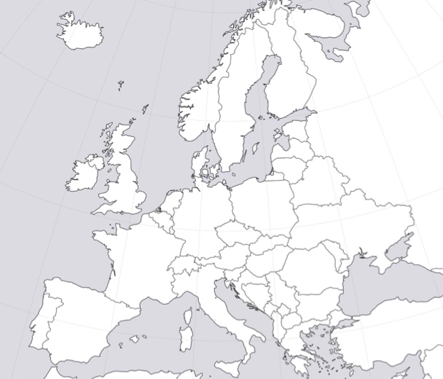
Farm hacks can play an important role in making connections and building networks between people and thus in strengthening social movements. Indeed, the first Farm Hack in the UK arose from an exchange and new connections between the Land Workers Alliance in the UK and the Greenhorns in the USA. Members of both organisations travelled to the other. This has provided opportunity for exchange of ideas and innovations. The participation of Scottish farmers in the first UK Farm Hack led to Farm Hack events in Scotland and has strengthened connections between the English-based Land Workers Alliance and Scottish farmers and organisations working on food sovereignty.
European locations

Links and other resources
- Farm Hack UK: https://landworkersalliance.org.uk/farmhack/ https://www.facebook.com/groups/FarmHackUK/
- Farm Hack Scotland: http://www.commongoodfood.org/technology/farm-hack-scotland-2016
- Farm Hack USA: http://farmhack.org
- L’Atalier Paysanne – is a related model for developing appropriate on-farm technologies using an open source approach. http://www.latelierpaysan.org/

About: Spotlight on Innovative Approaches to Learning

These brief documents are prepared as a part of the European Agroecology Knowledge Exchange Network (EAKEN). They are meant to help those interested in political Agroecology to think through which pedagogies, methodologies and approaches are being used in Processes of agroecology and food sovereignty learning and knowledge exchange.

Visit www.XYZ.org to learn more about EAKEN and to view other briefs.

What does an agroecology learning approach Look like? It…

- Is based on peasant knowledges and cultures;
- Where the political vision of food sovereignty informs the practical aspects of peasant farming;
- Is rooted in the territories and their local communities;
- Focuses on horizontal pedagogical methods;
- Creates a ‘dialogue between ways of knowing’ (diálogo de saberes);
- Aims to build international peasant agroecology movement for mutual support and resourcing;
- Works to protect peasant knowledge and know-how as a commons for all

From the statement of European Agroecology Knowledge Exchange Network.

This document was prepared by the “resources working group” of AEKEN:
Colin Anderson, Centre for Agroecology, Water and Resilience (CAWR) – colinanderson@coventry.ac.uk
Annelie Bernhart, CAWR
Chris Maughan, CAWR
Jildou Friso, Toekomstboeren ( )
Kaya Thomas ( )

Contact: info@eurovia.org for details about the AEKEN network.

See: http://www.latelierpaysan.org/Pour-une-souverainete-technologique-des-paysans
https://creativecommons.org

